Cliff Andrews - BRCC Deputy Chief Executive

Mike Fayers

(both have a background in countryside management, and have been working for BRCC for c.20 years)

Kim, Claire, Julian

Cliff shared a presentation. Would usually run a workshop with the community.

Definition - Luton & Beds GI consortium 2007.

Bedford Borough created a GI Plan in 2010.

BRCC felt borough borough-wide GI Plan was top-down and so developed a methodology for parish level GI Planning. About 60 parishes across Beds. have a parish-level GI plan. BRCC has led on over half of these.

BRCC do the ‘leg work’ but the meaningful content comes from the local residents.

In more recent years, NP process has been the catalyst. Valuable as part of the environment sections of NPs.

Beds. is a rural community in general and the local environment comes out as a priority for the NP.

GI Plans don’t just sit on shelves - more community-driven NPs and engagement.

Examples:

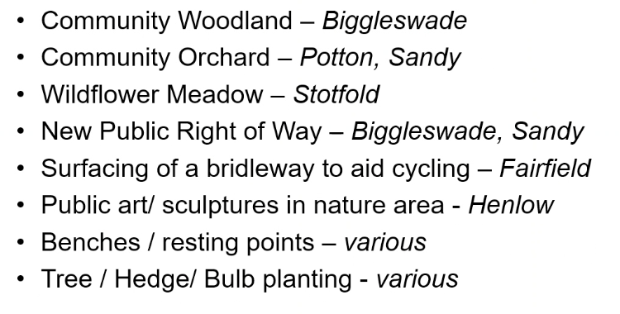

What is the process?

1. In-person workshop to start the process for local residents - completely open to the parish residents
2. Follow-up surveys and prioritisation process can be done online

Takes about 3-4 months, and then another 2-4 months to produce the GI Plan.

Then, they will produce the GI Plan, which can be used directly by the community to plan and deliver GI projects and to guide policies in the NP.

Map-based. GI Map Pack.

Context map, Landscape map, biodiversity map (habitat basis - though doesn’t map species), historic environment map. Acts almost as a constraint map - shows where you can not plant a woodland/ dig a pond, etc. But also serves to highlight potential to celebrate local heritage.

Final map - access, open space and recreation map - public rights of way, green spaces (1. ‘accessible’, 2. ‘formal recreation areas’ - allotments, sports grounds, cemeteries - may have restrictions on them in terms of access or use, 3. ‘Non-accessible green space’ - privately owned green space, woodland, etc. that has biodiversity and possible heritage value - forms part of the GI of the community - just because people can;t use it/ access it, doesn’t mean it’s not valued.

‘Local Green Space Designation’ - allows to protect *some* green spaces (a bit like a green belt). Not intended to be a way of ‘blocking’ houses/ development. Criteria to meet in order to have such designation.

Which are the *most important* green spaces?

In the workshop - next exercise would be to work in groups - blank map to start plotting any aspirations for enhancing the green environment and local GI network. Ensure it’s a consensus-built approach. Footpaths cycleways/ bridleways. Views. Any other features.

Anything in the GI Plan has to come from the community. And be consensus-led.

Make a draft map if it comes from 2 groups. Keep all maps.

Further consultation - drop-ins, webpage, etc.

Revisions and prioritisation exercise.

Write up the final GI plan and action plan.

Establish: Level of priority? Level of resource? Who needs to be involved (e.g. Rights of way dept., landowner, BRCC, etc.)?

One option - can be to put in section 106 funding/ developers include some of the aspirations of the GI Plan in developments.

Planning for climate change - dealt with more in the general environment section of the NP, but there as aspects of the GI which would overlap/ be relevant. E.g. solar panels, water butts, etc. would not be in the GI Plan. The GI Plan is more things that can be mapped.

*Cost?*

Size of parish is as relevant as the size of population.

Border with Cambridgeshire adds a little more in terms of cost - as need to ‘buy in’ data from surrounding counties.

GI Plan - Mike and Cliff - printing, etc. around £4.5k

Local community - NPSG or RPC to pay for hire of hall, etc.

Local green space assessment - costs will depend on what/ how many areas the community want assessed. £600-800 for the assessment (for roughly 5-8 sites - it would be less if only one site is to be assessed)

Actions:

* Put this on the agenda to discuss and decide upon (whether to go ahead) at the next NPSG meeting
* If so, need to apply for funding from *Locality!* So would first get an official quote and use that in the application. Don’t apply until April. GI workshops and GI plan developed over the Summer.
* Also, discuss - do we need other workshops for other topics/ elements of the NP?

*Housing Needs Survey? Email Jemma McClean (lead on local housing). Cost dependent on scale of community. C. £3k.*